Assignment-3 EES405

RIMJHIM GOEL

MS18133

Que2

\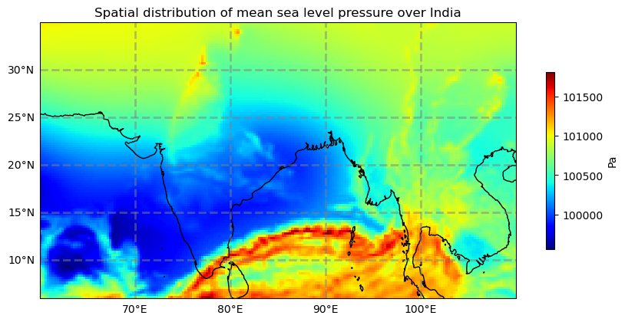

Que3

1. Spatial distribution of winds at 850 hPa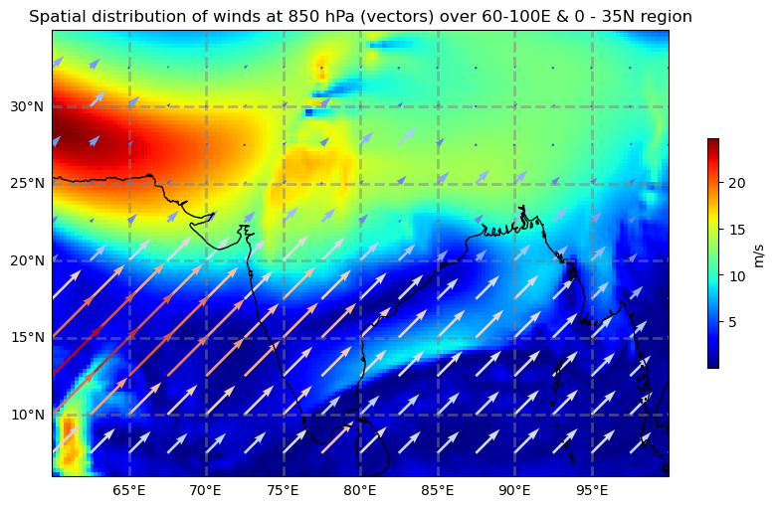
2. Spatial distribution of winds at 200 hPa.

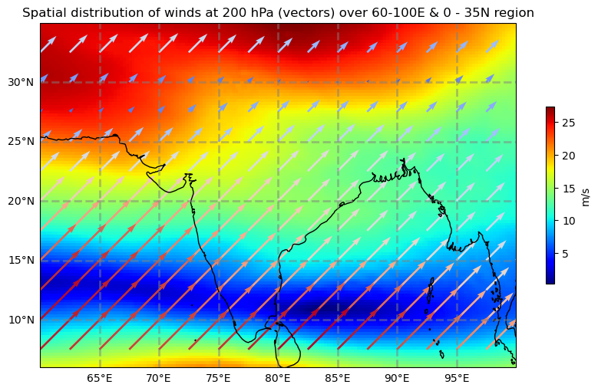

Que4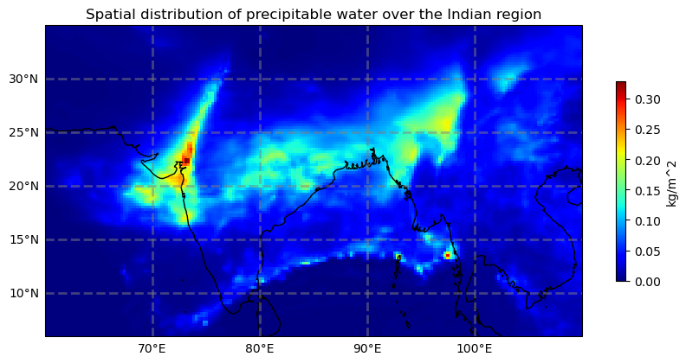

Que5

